Capstone Data Analysis Notebook
Use this document as central location for all my notes.
Table of Contents
Right Now 2
June 8 2
Underserved, What Does it Mean? 2
500 Cities Data Files 3
Measures 3
Unhealthy Behaviors 3
Health Outcomes 3
Prevention 3
Measure Definitions 4
Measure Definitions Sample: Health Outcomes for Arthritis 4

Right Now

June 8
I’m in the analysis phase. Starting to look at the health-related data and making notes so that I understand what I’m looking at.
500 Cities dataset measures 27 different health-related data points, by Census Data Tract. I’m using this to give an overview of the city’s health on a Tract-by-Tract basis. These Census Tracts will form the basis of my examination within the city.
I’ve plotted the Nashville 500 Cities info in Tableau. This gives me an interactive map that returns result sorted by Category and Short Question Text. Info from this worksheet will be helpful in determining risk factors for people in different areas of town.

Underserved, What Does it Mean?
In the context of this project, Underserved refers to areas with fewer health-care facilities and/or higher than average rates of chronic health issues. I’m using Census Tracts to subdivide the city as that’s a more accurate way to do it [see reference].
Underserved ==
fewer(AVG(healthcare facilities)) && ||
higher(AVG(health issues))

June 9
Have made a good bit of progress today:
- Updated README
- Joined provider addresses with geocodes and plotted on map
- Created two-layer (dual-axis) map with 500 cities and geocoded addresses

I had been thinking next step should be to spatial join city boundaries with 500 cities but now not sure. I think it might be better to convert the 500 cities data (sorted by Census Tract) into spatial data, then make a dual-axis map.
Another option is to look into adding both maps to layers on a dashboard. That may give me the most control over what shows up.
Dashboard layers work great except that alignment is difficult and no way to sync zoom between layers. https://www.tableau.com/about/blog/2018/11/express-your-data-artistry-transparent-worksheets-tableau-98807

June 10
Made no progress last night trying to join the Census Tract Map with the Existing Locations Map. From the documentation, it seems that a spatial join is the way to go, yet the results never include what I’m looking for. I want a spatial file containing the polygons for Census Tracts and the points for Existing Locations. What I get is a file that contains either polygons or points, but not both.
Here are suggestions from UrLeaka:

Questions.. (things to try one at a time)
- consider rerunning cells to create all_providers_geo again before you run "results"
- check out dtypes for each column in both dfs (i.e. all_providers_geo.dtypes)
- what about a spatial index? create one for left df… https://geopandas.org/mergingdata.html (see end)
- consider using op = intersects (want any possible way geometries can interact)
- what happens if you switch left and right dfs? (if the above steps don't work, try this)
- check out these two, it looks like after sjoins are performed, only one geometry results depending on your index I imagine.
  - Spatial joins in GeoPandas
    - You can join two GeoPandas GeoDataFrames through conventional means with merge, but you can also use sjoin to capitalize on the spatial…
    - https://medium.com/@bobhaffner/spatial-joins-in-geopandas-c5e916a763f3
    - This didn’t work for me
  - How to easily join data by location in Python — Spatial join
    - How to do spatial join easily in Python and Why it is a powerful tool often ignored in data science.
    - https://towardsdatascience.com/how-to-easily-join-data-by-location-in-python-spatial-join-197490ff3544

Still having issues with this. Have posted a question to Tableau Support: https://community.tableau.com/message/1095725#1095725

Geocoding Addresses
The addresses file will go through the geocoder and return the following format: "","xxx","" This is a comma-delimited format with double quotes around each cell. I've been going into BBEdit and deleting the double quotes. The file loads fine after that, but you'll still need to specify column names on import, see below:
Keep these columns
- address
- city
- state
- zip
- longitude
- latitude

The geocoder will reject some addresses as no match, even though it will return the coordinates when the address is entered manually. I’ve entered manual coordinates where I can, taking care to estimate the general area where more accurate coordinates are not available.

Census Data
Census Data API key is 473a56bb2668bdd5c0b74c326e42ee42c4f94767

Health Outcome Maps
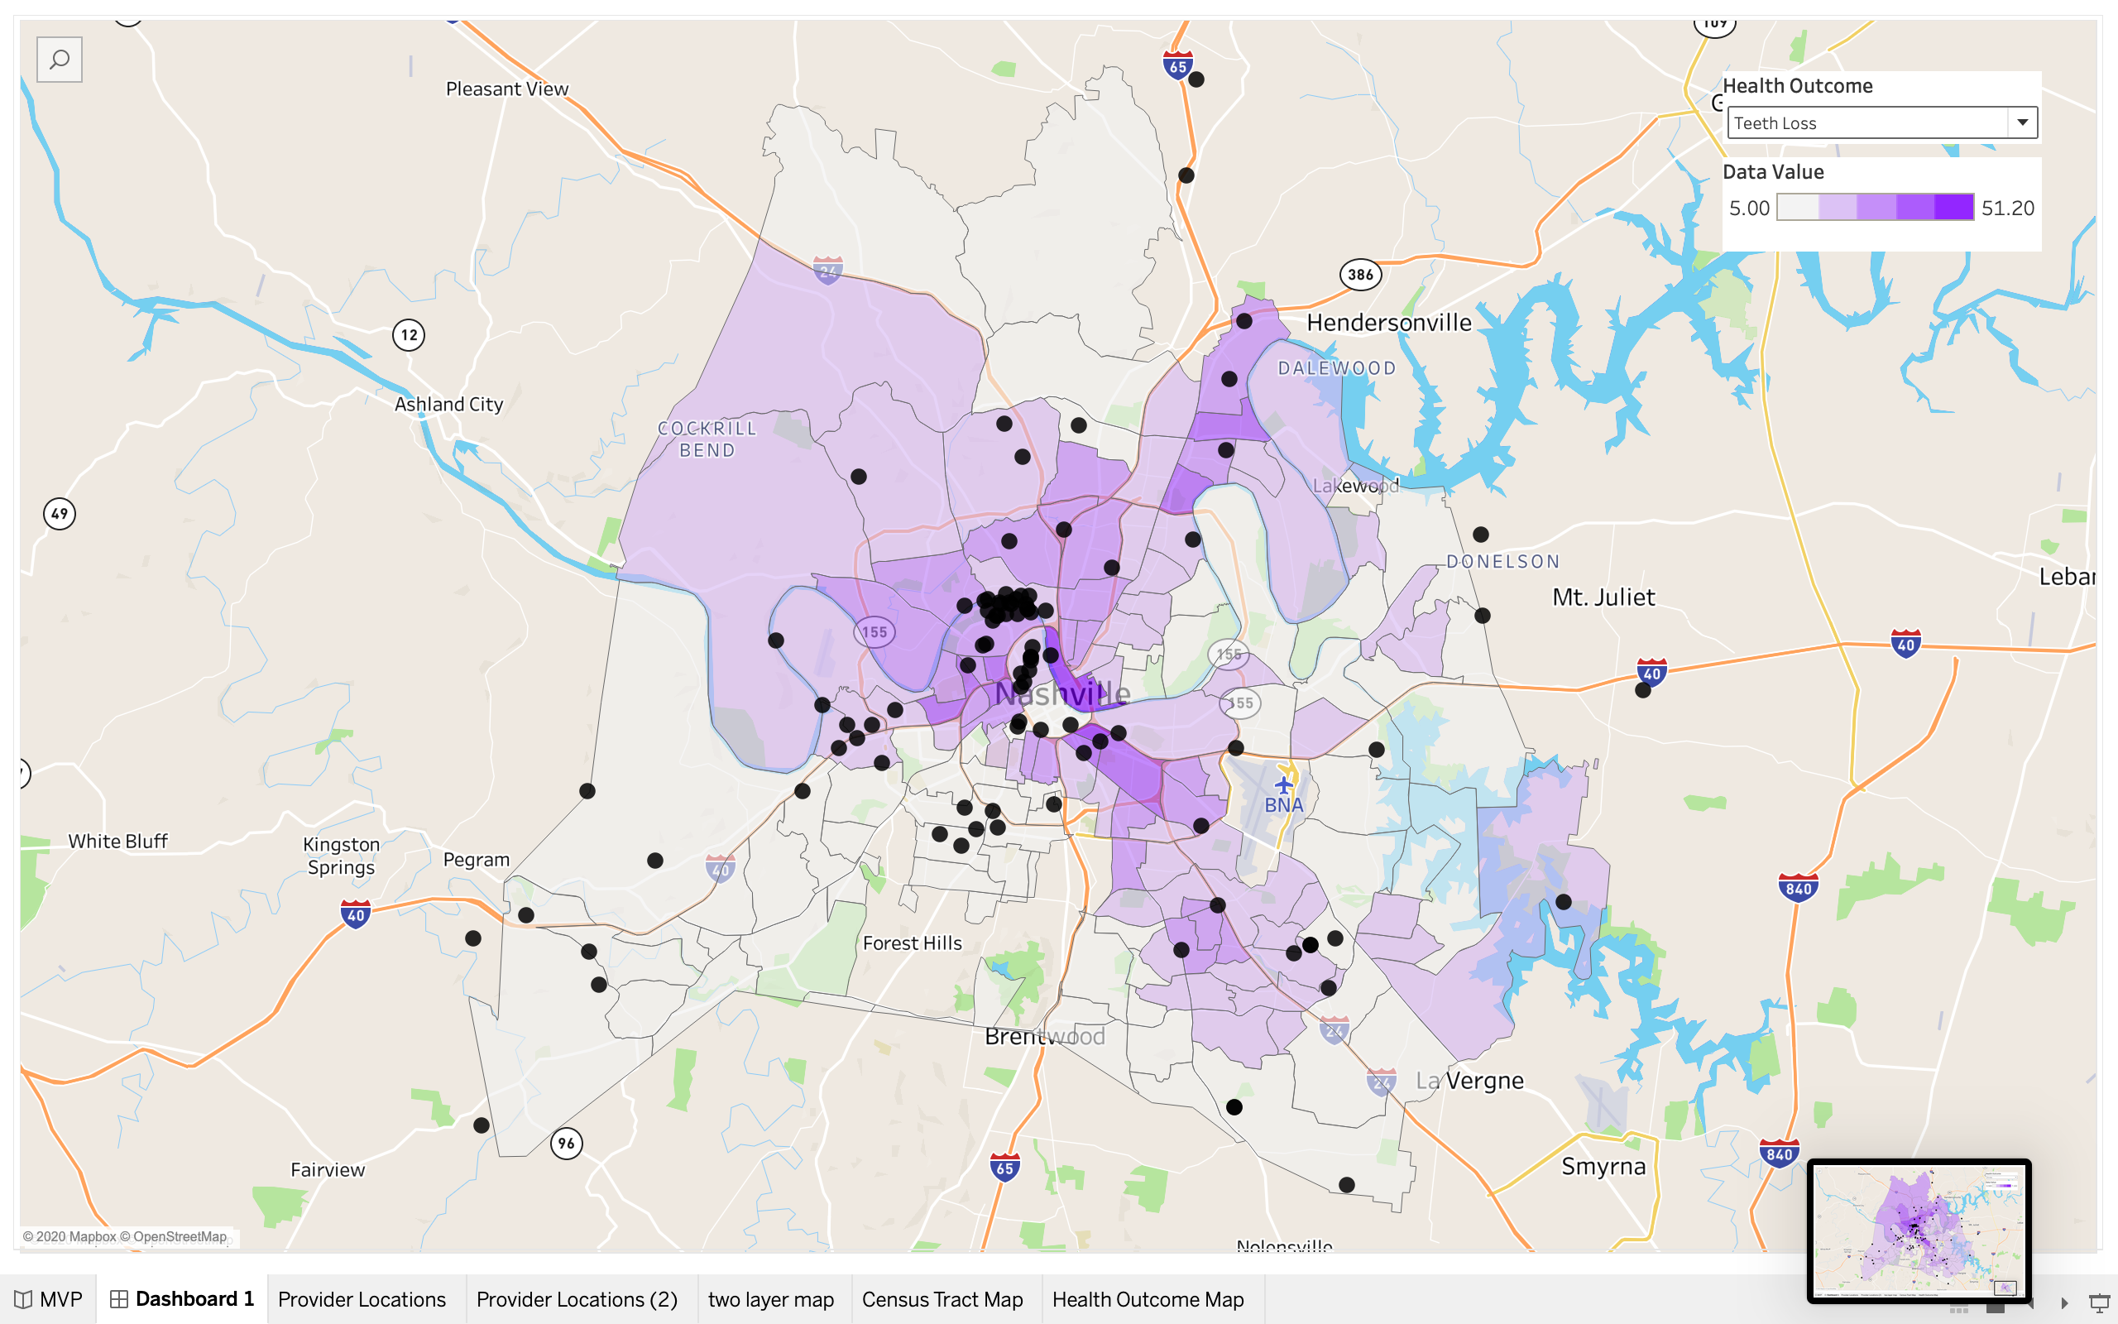
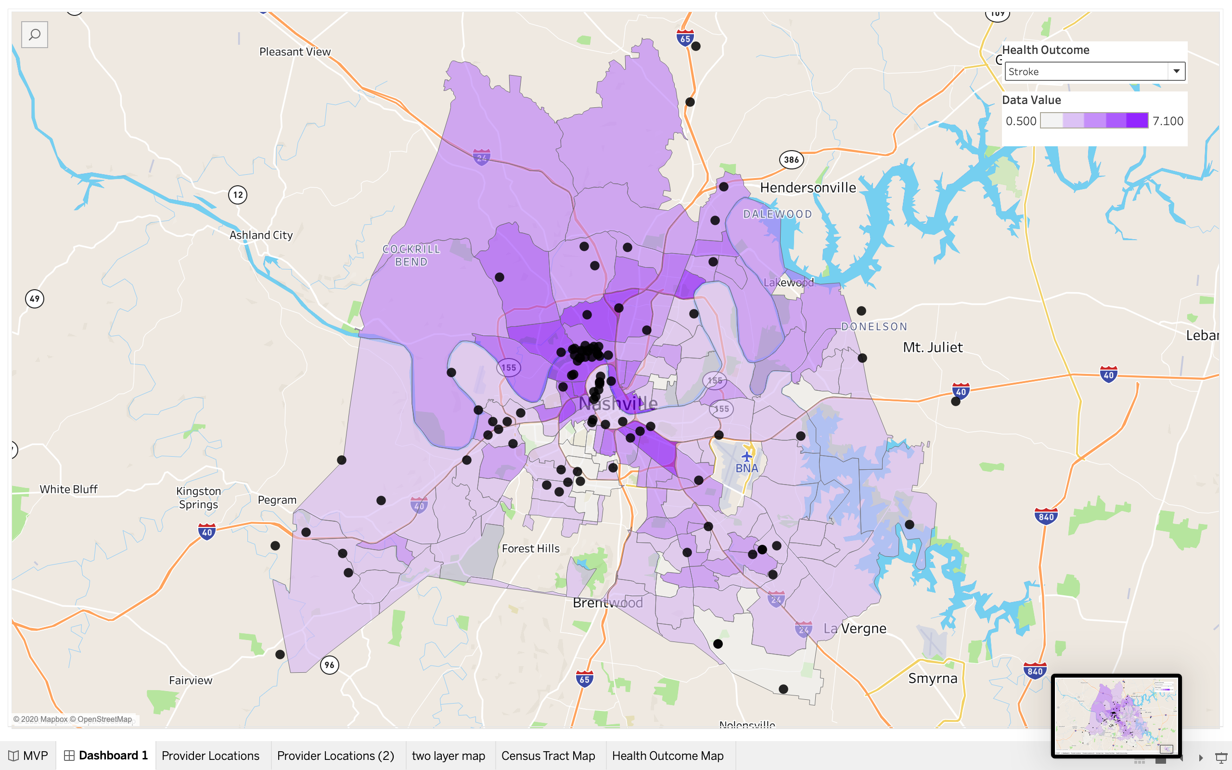
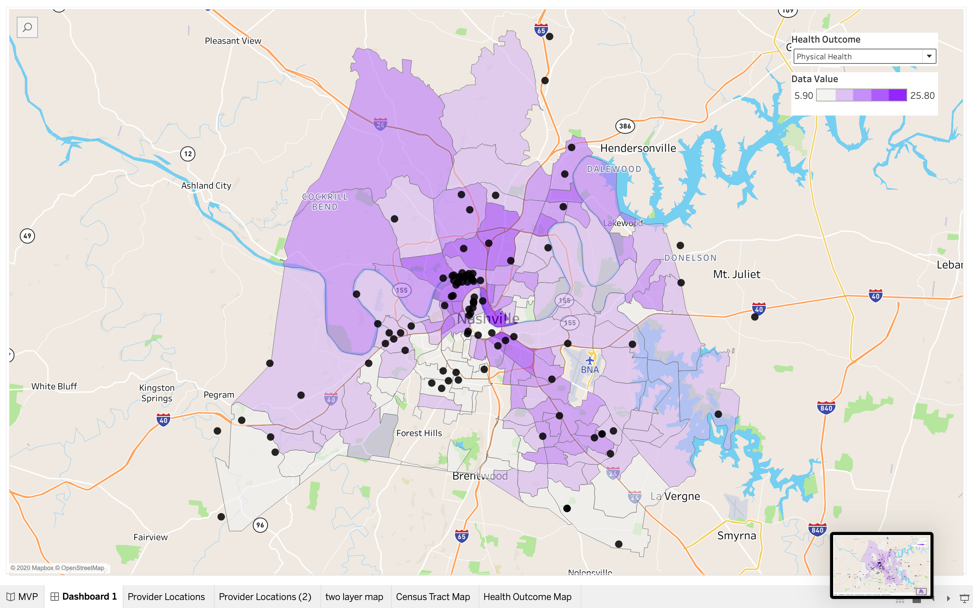
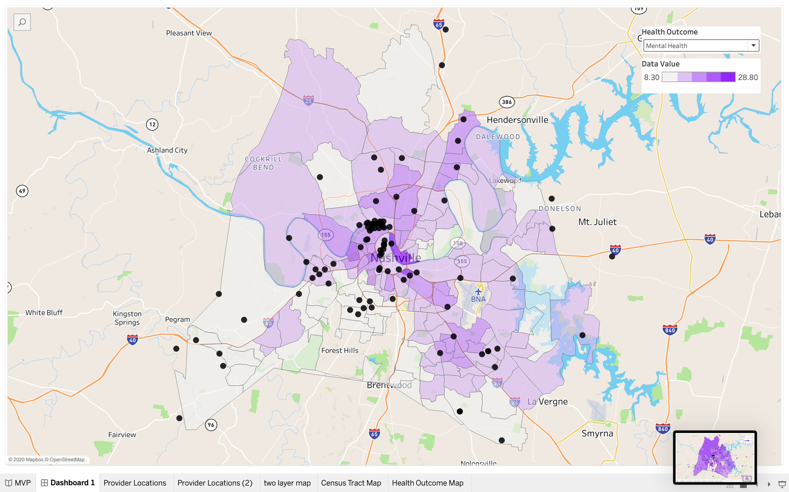
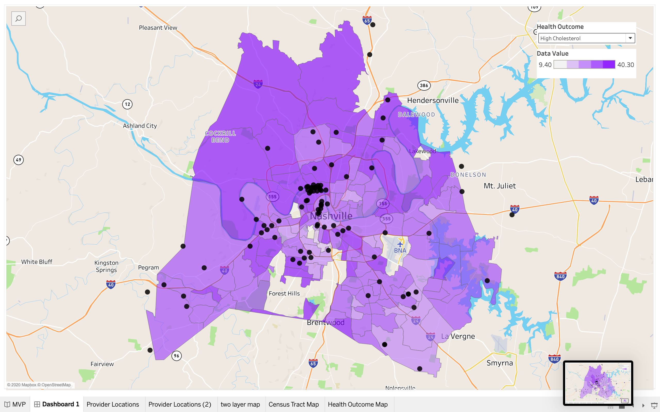
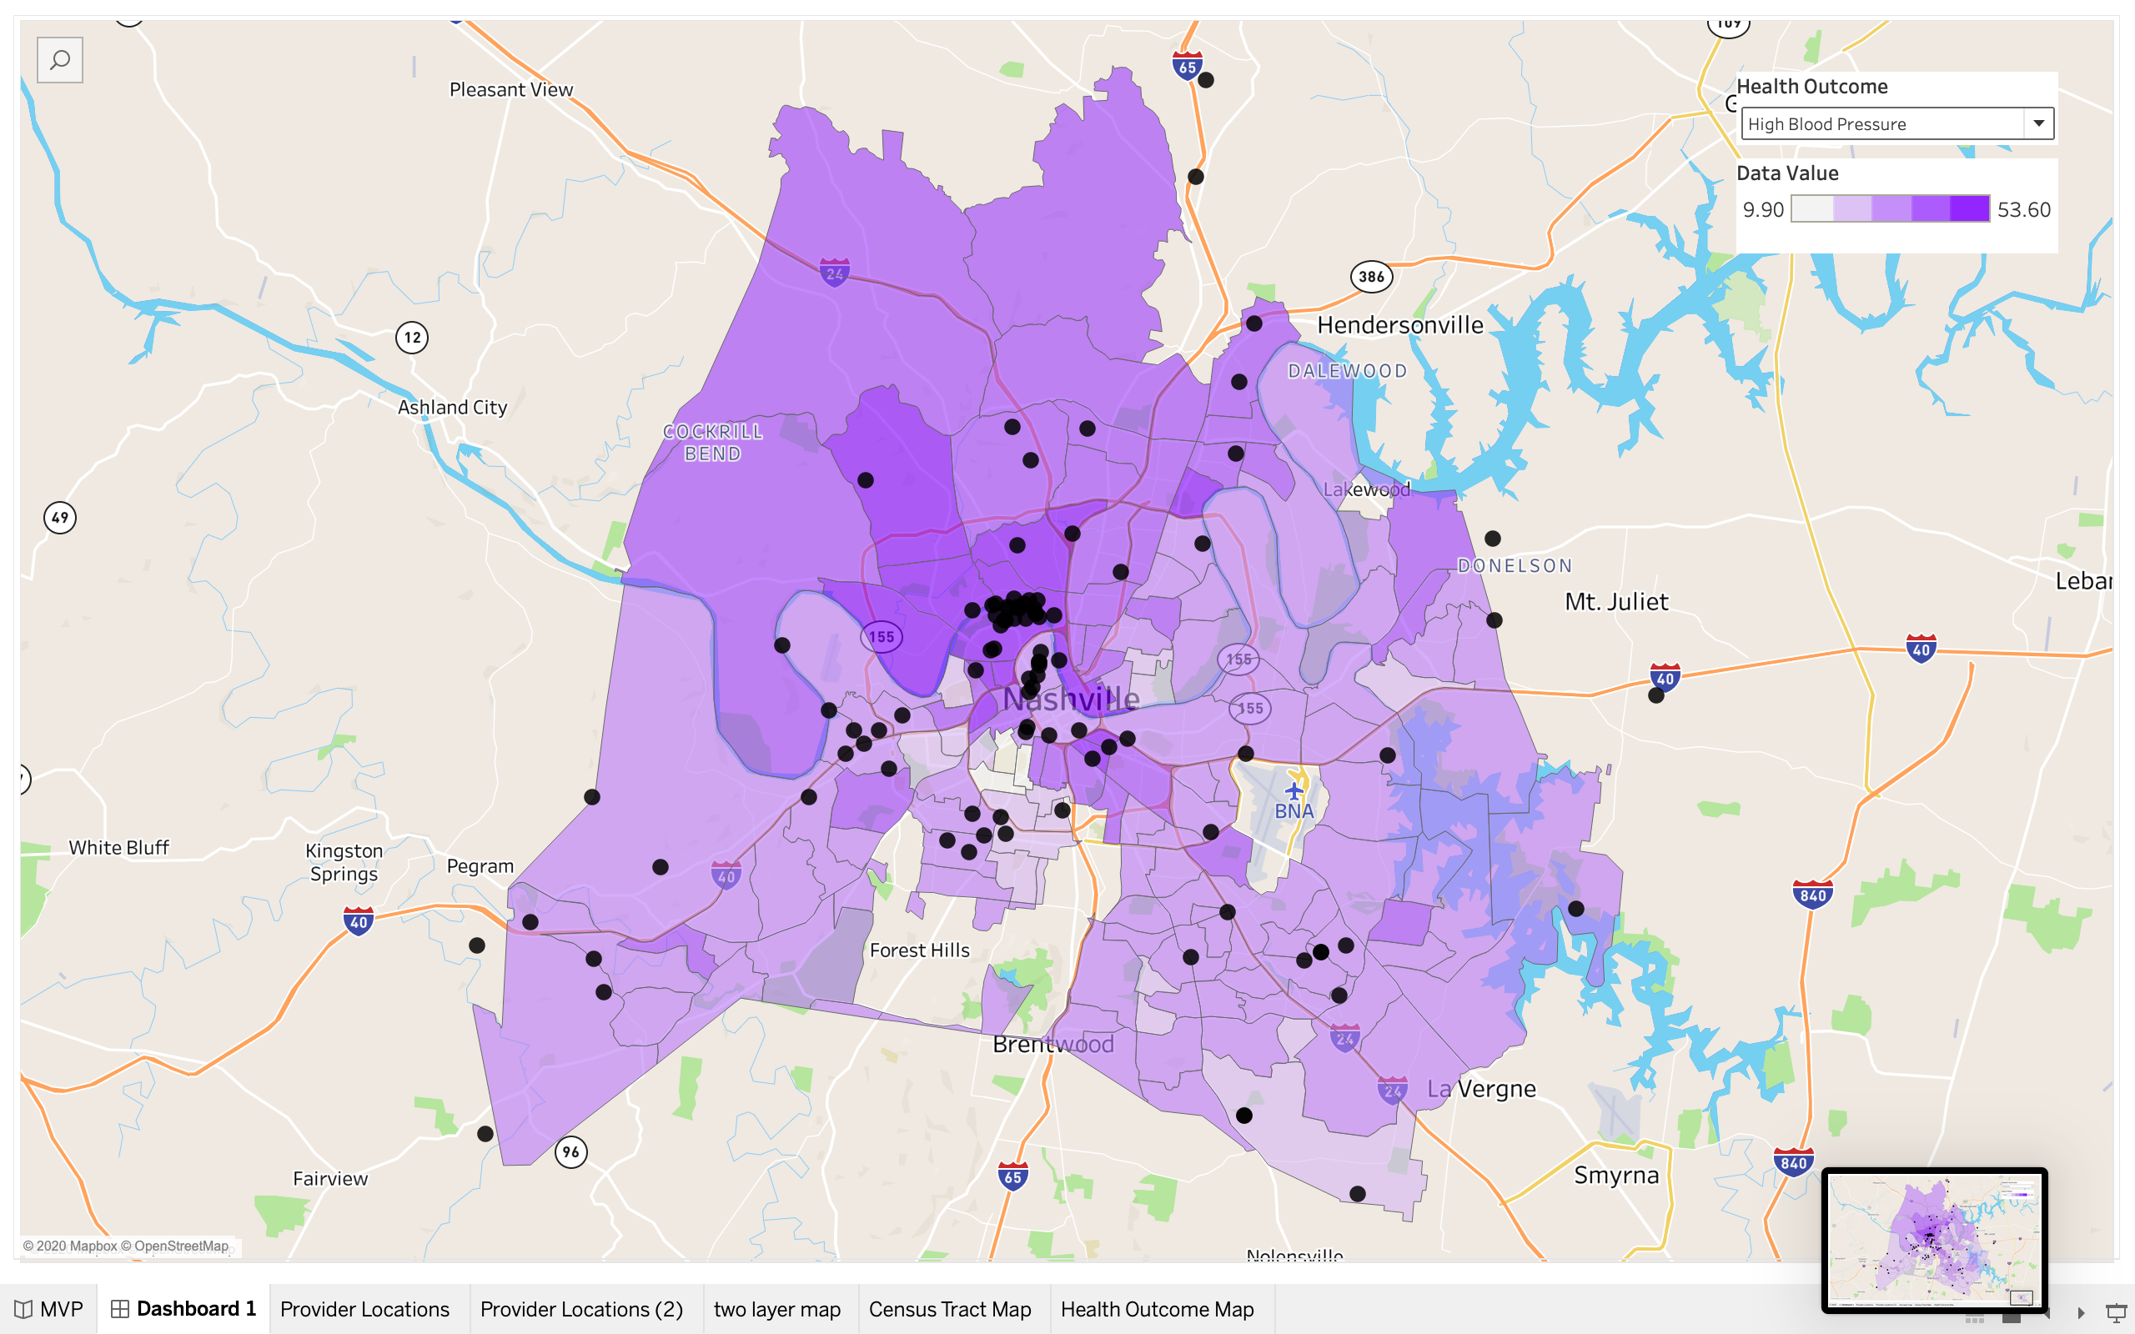
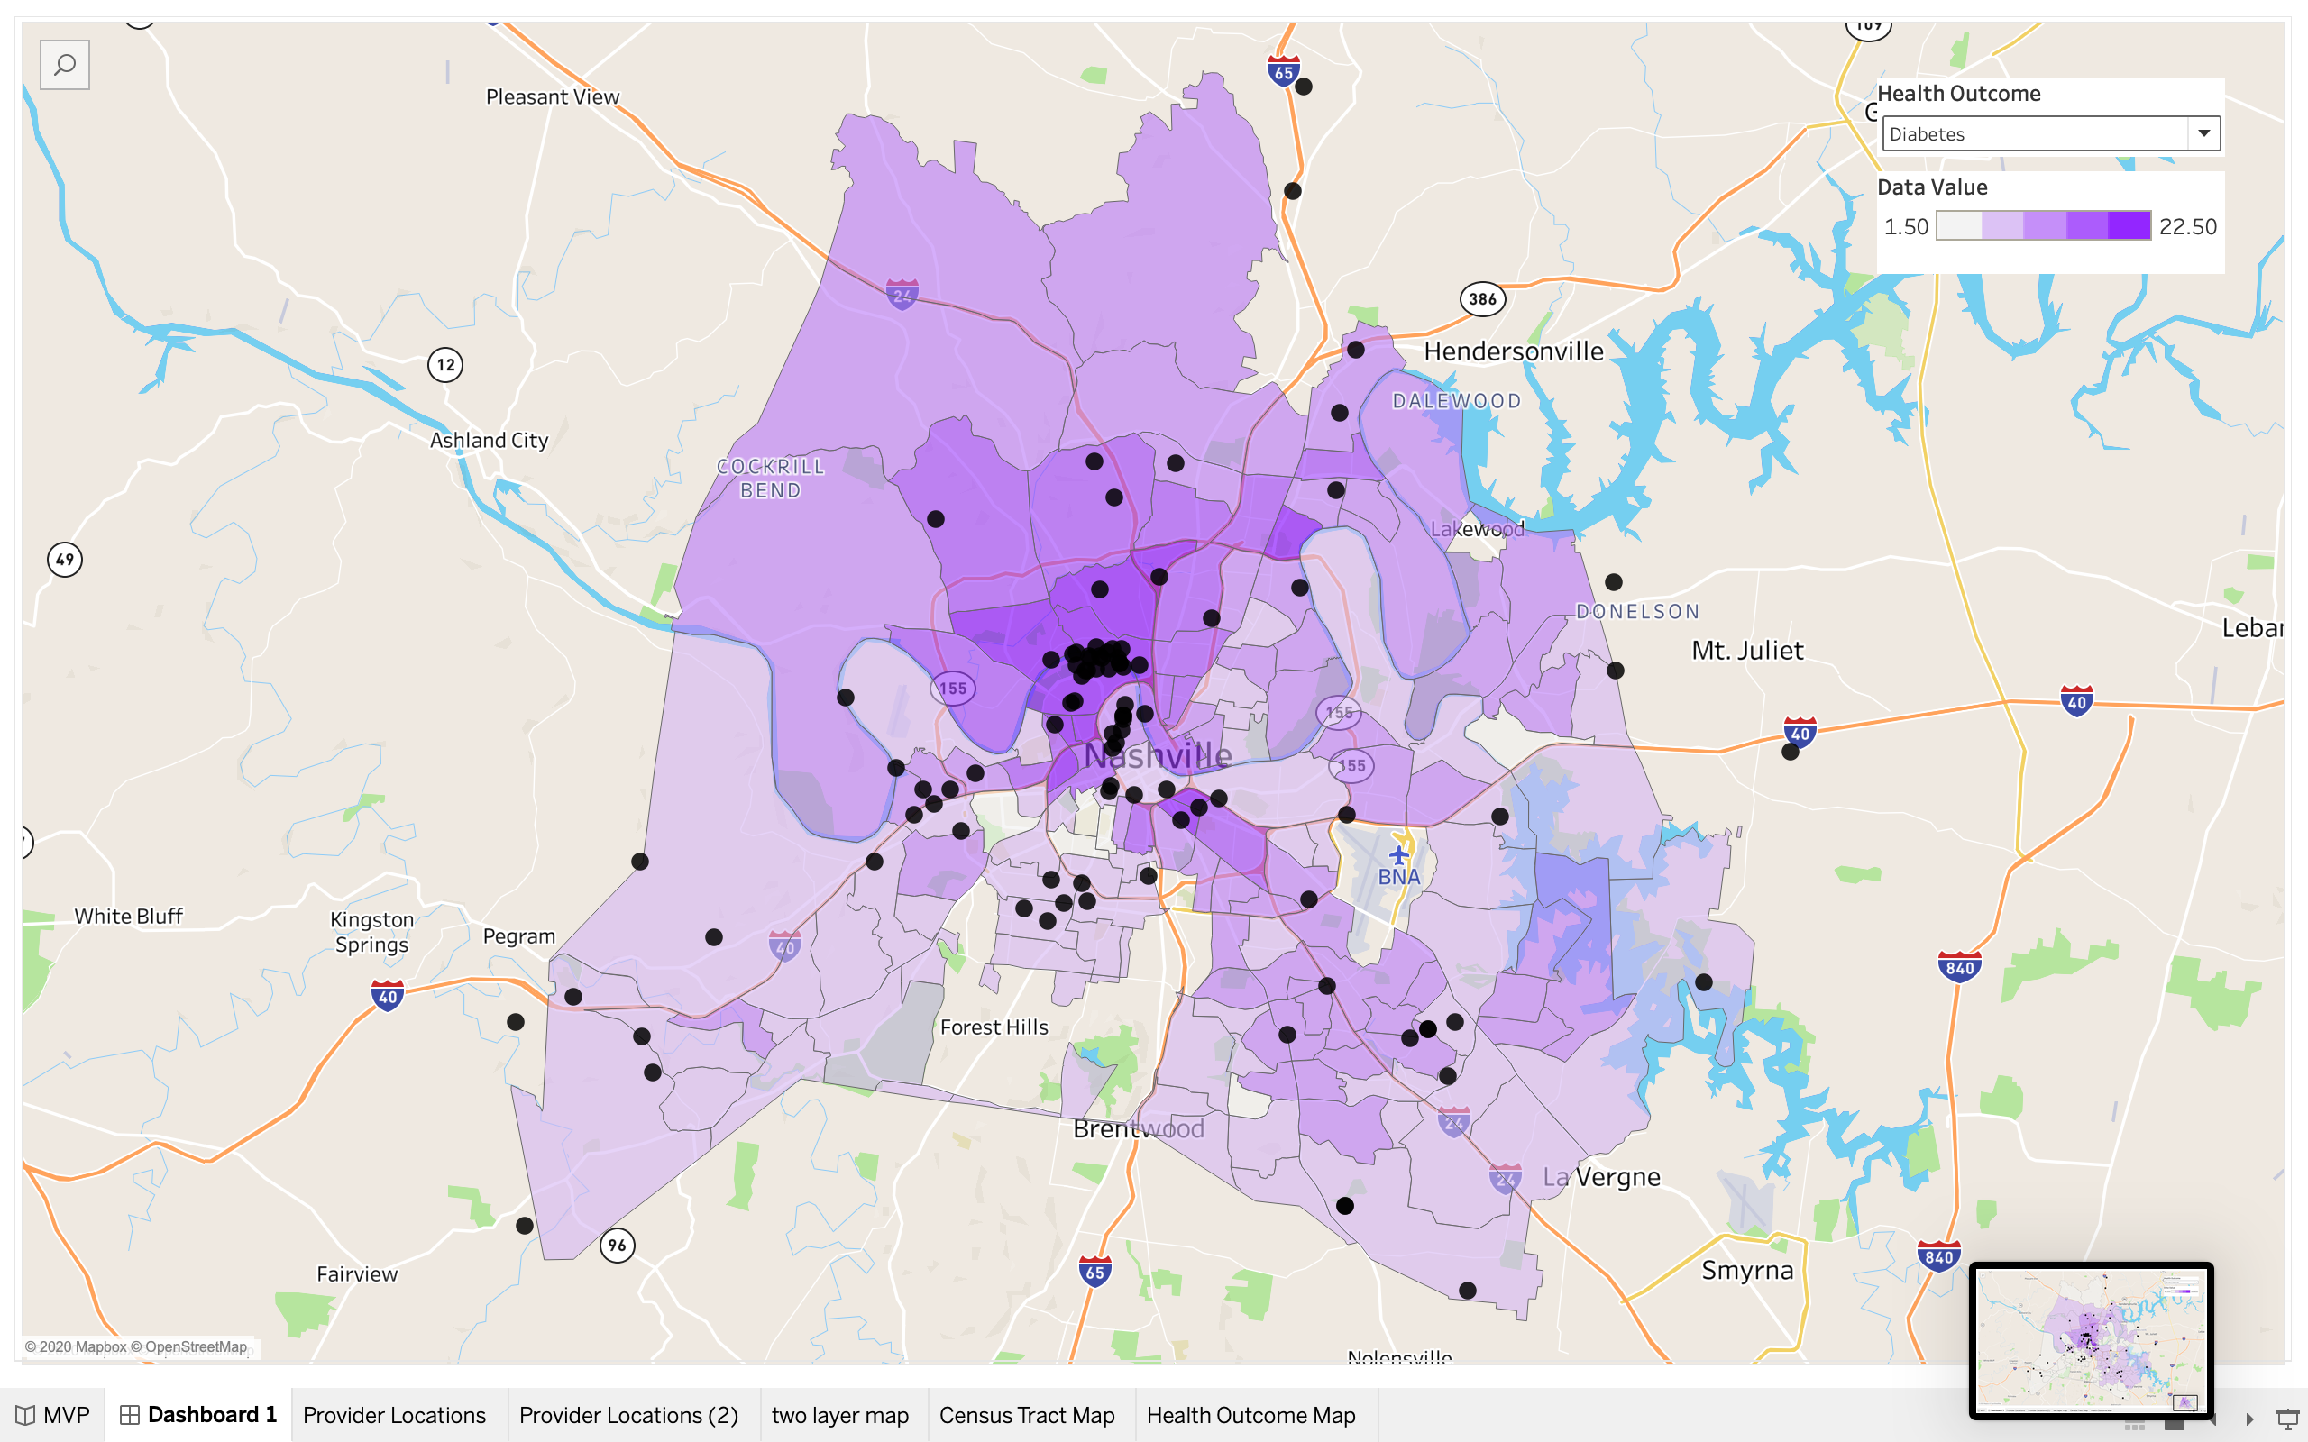
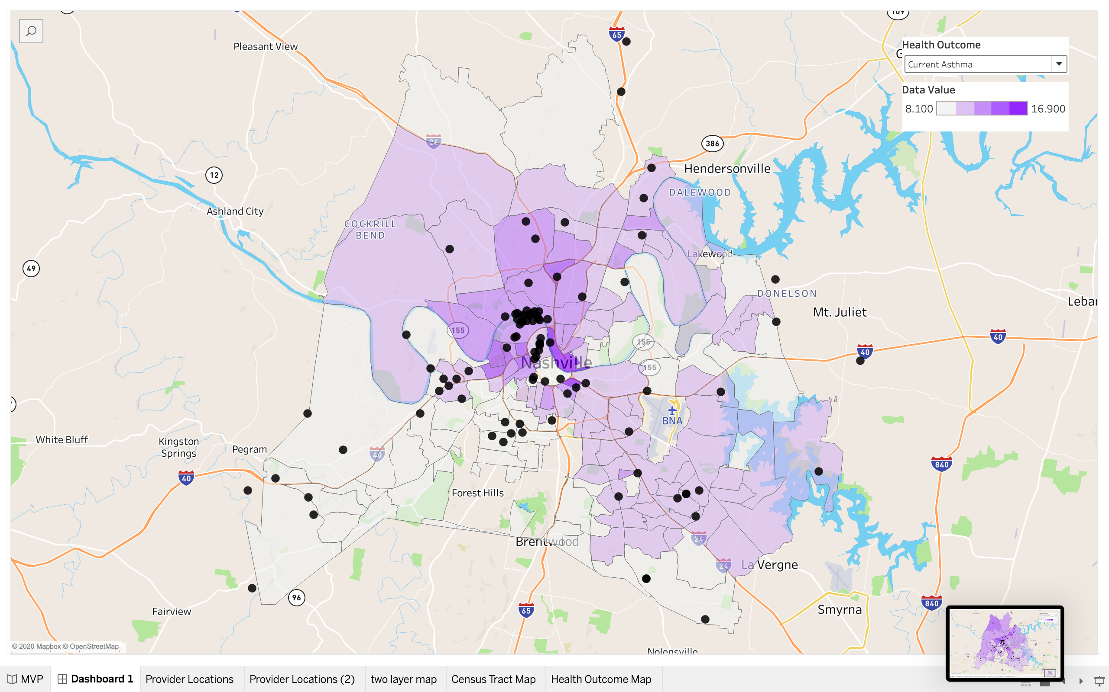
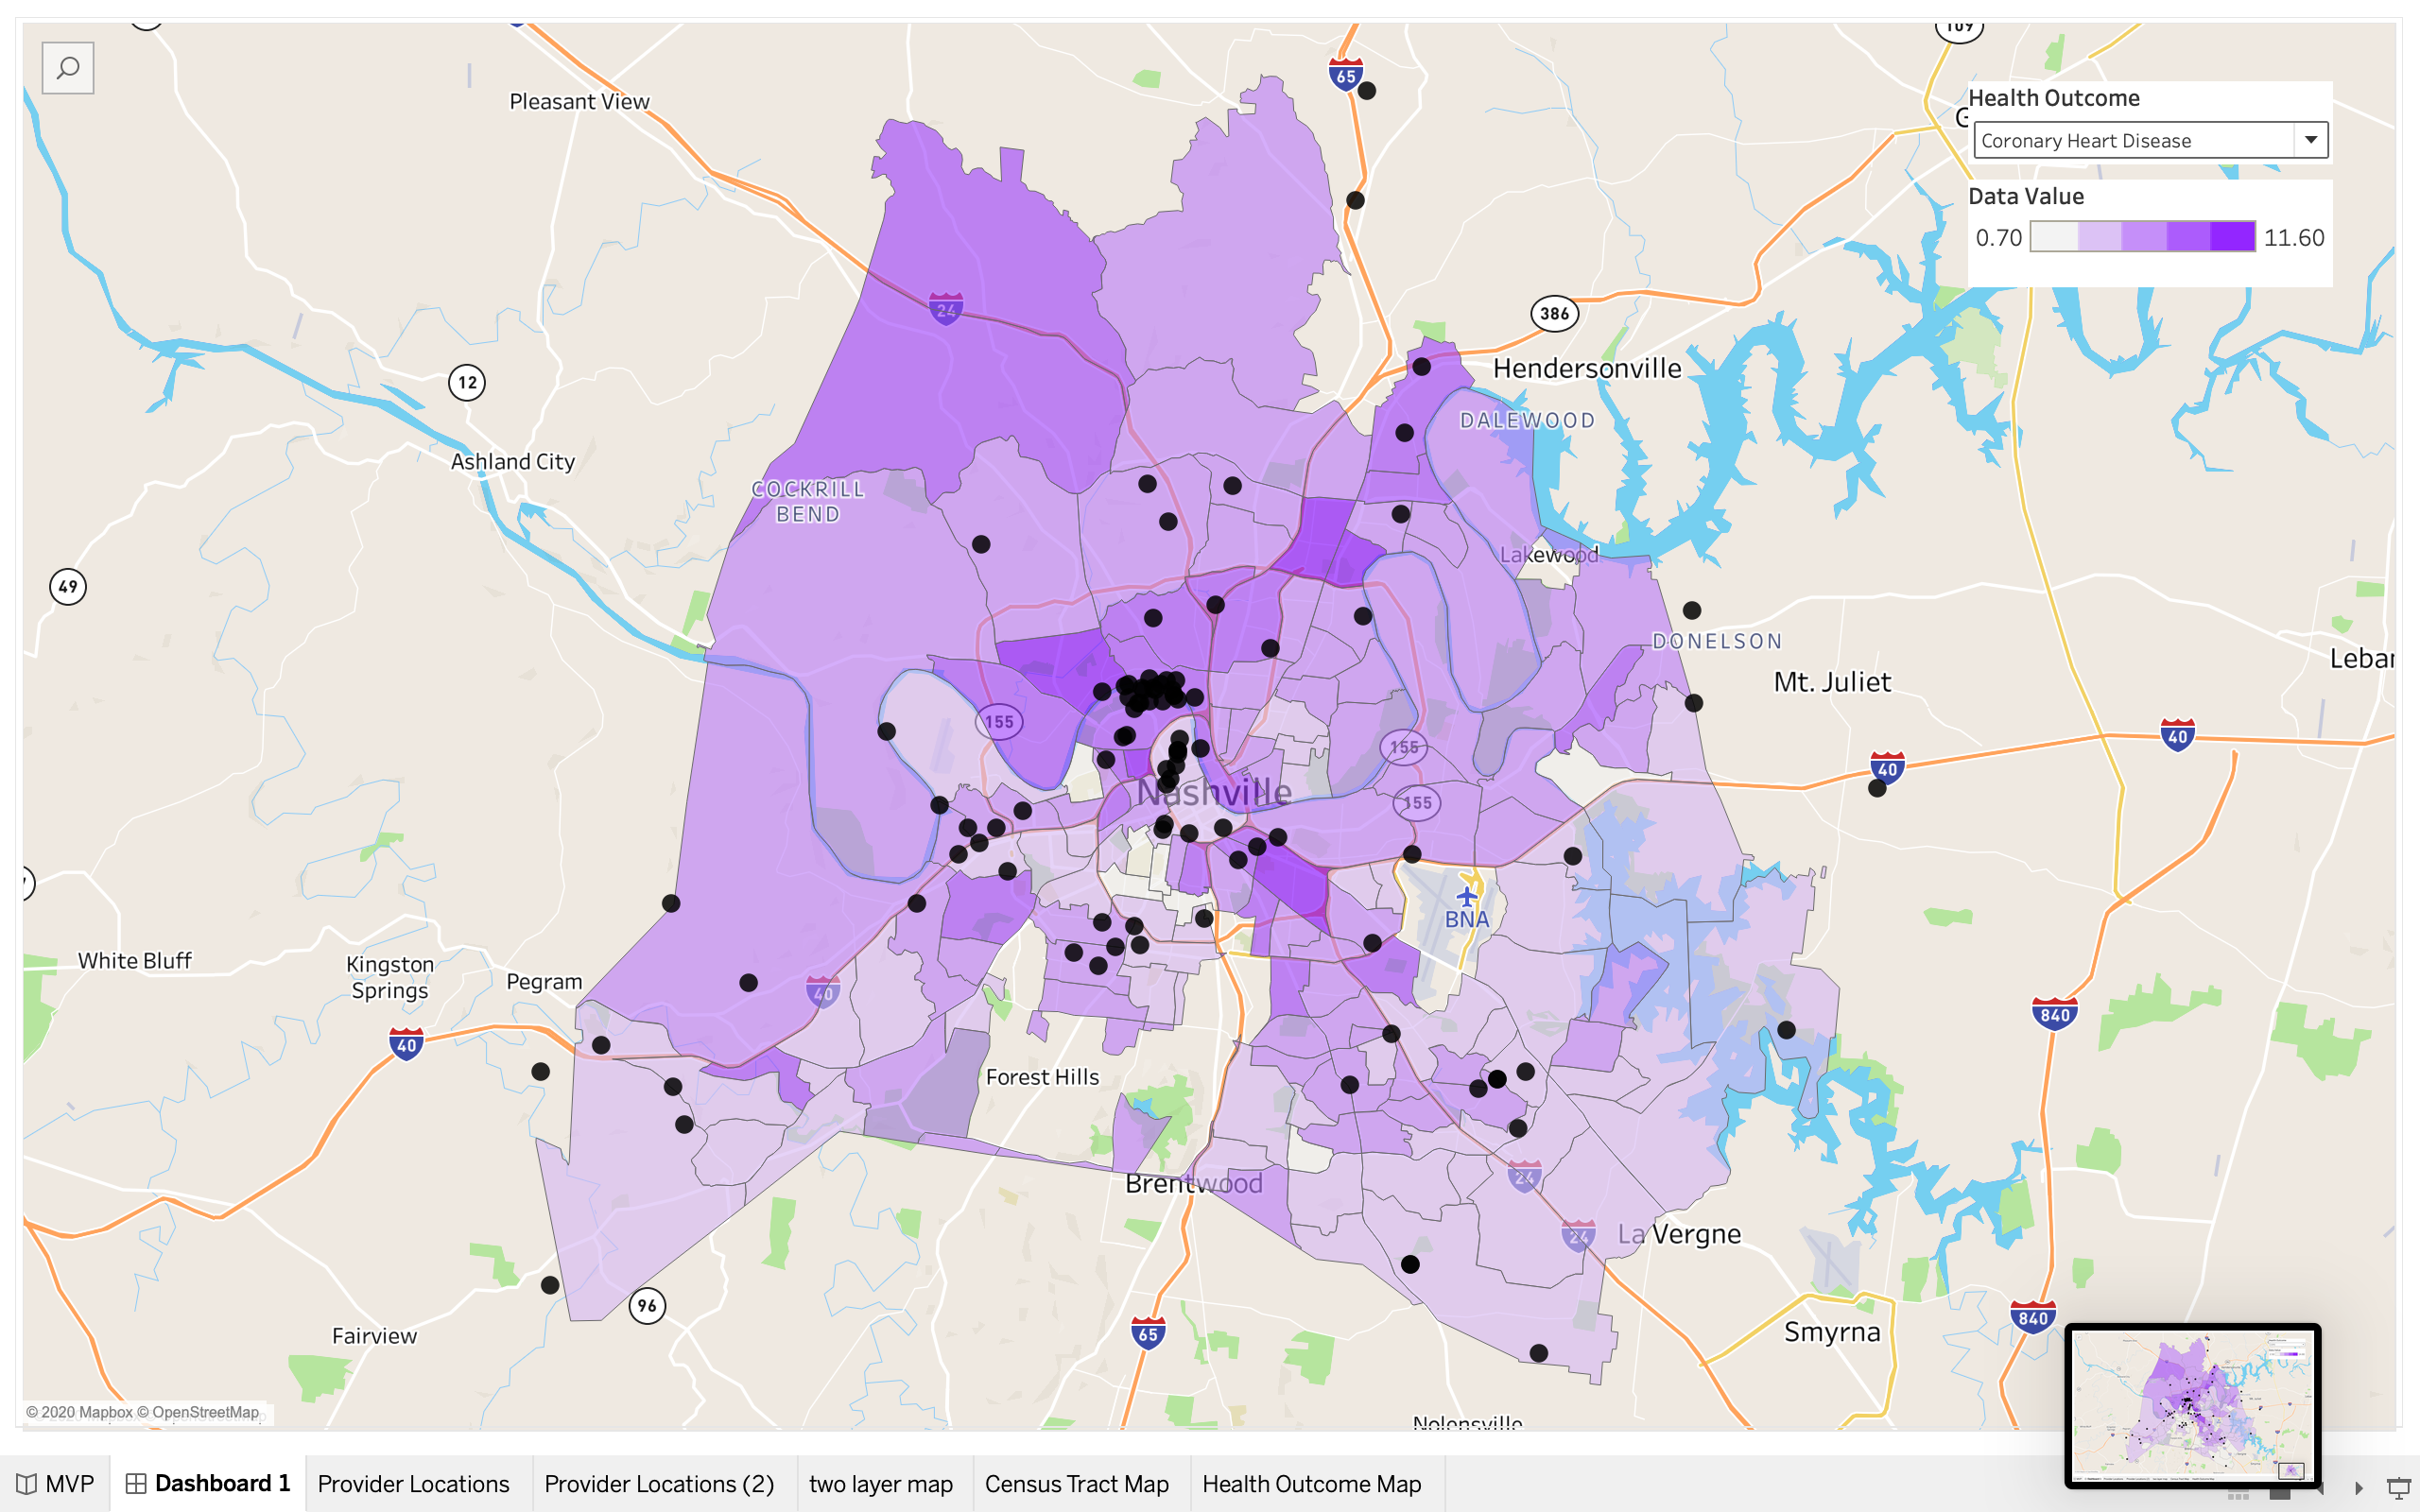
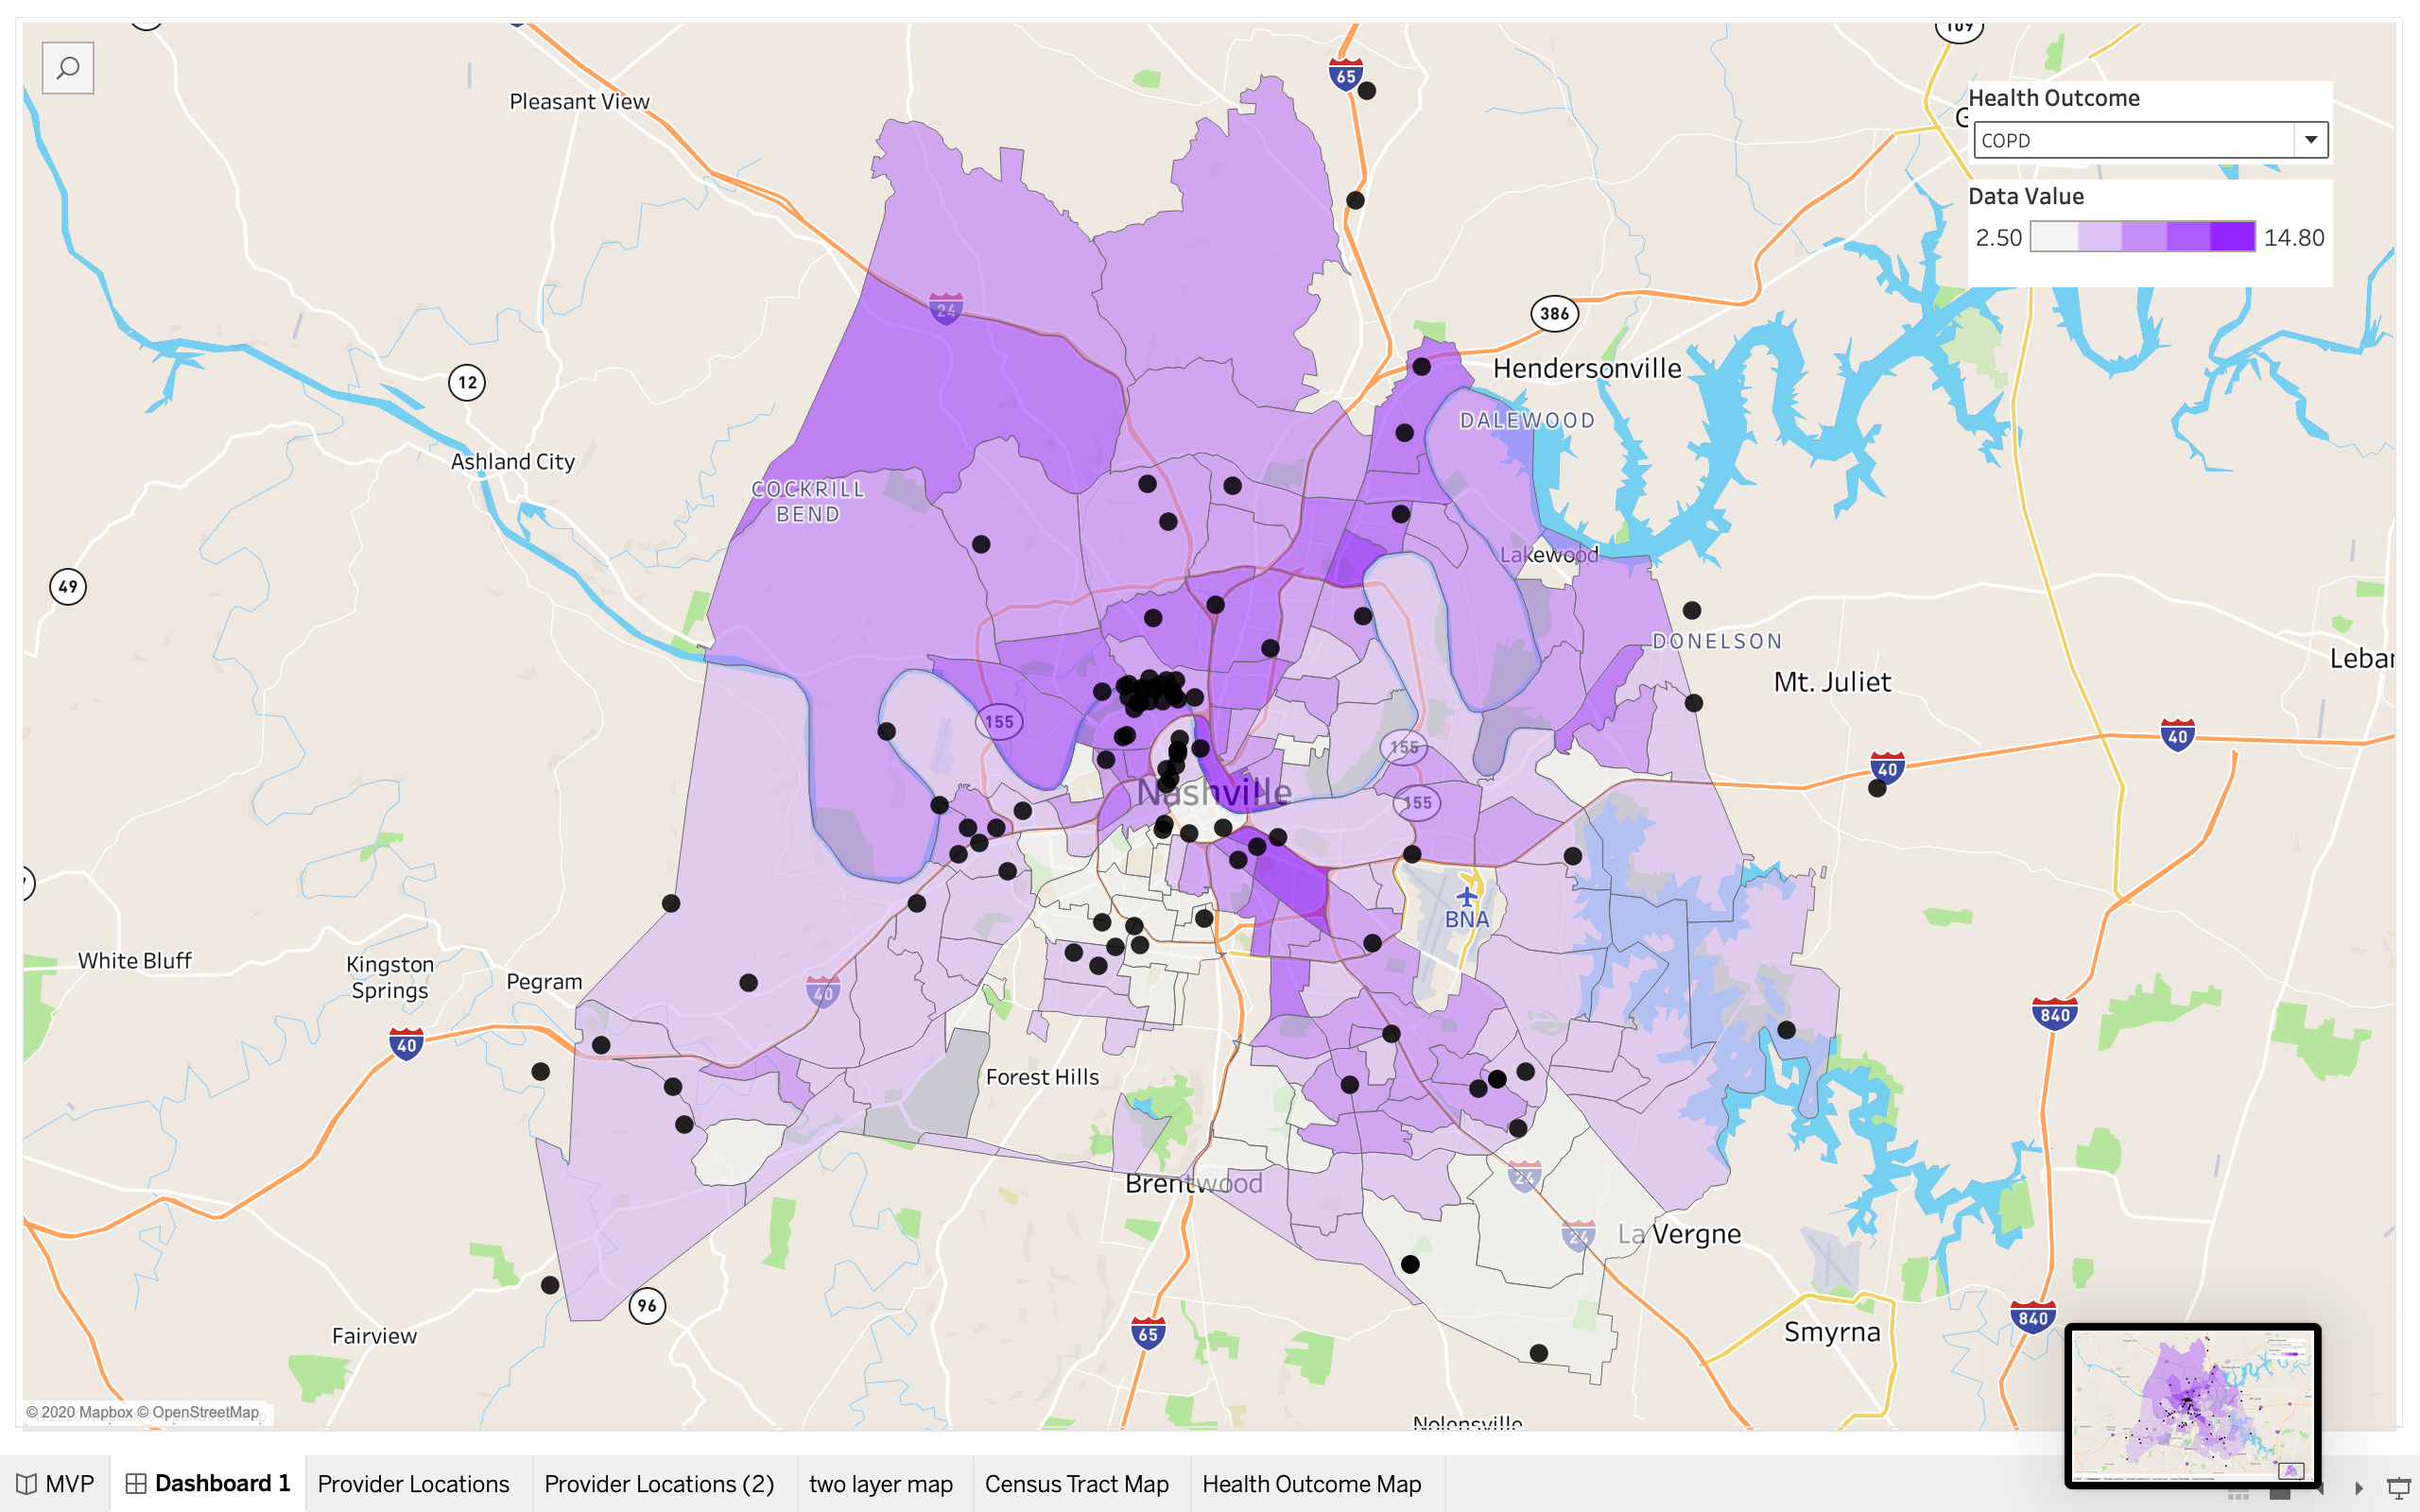
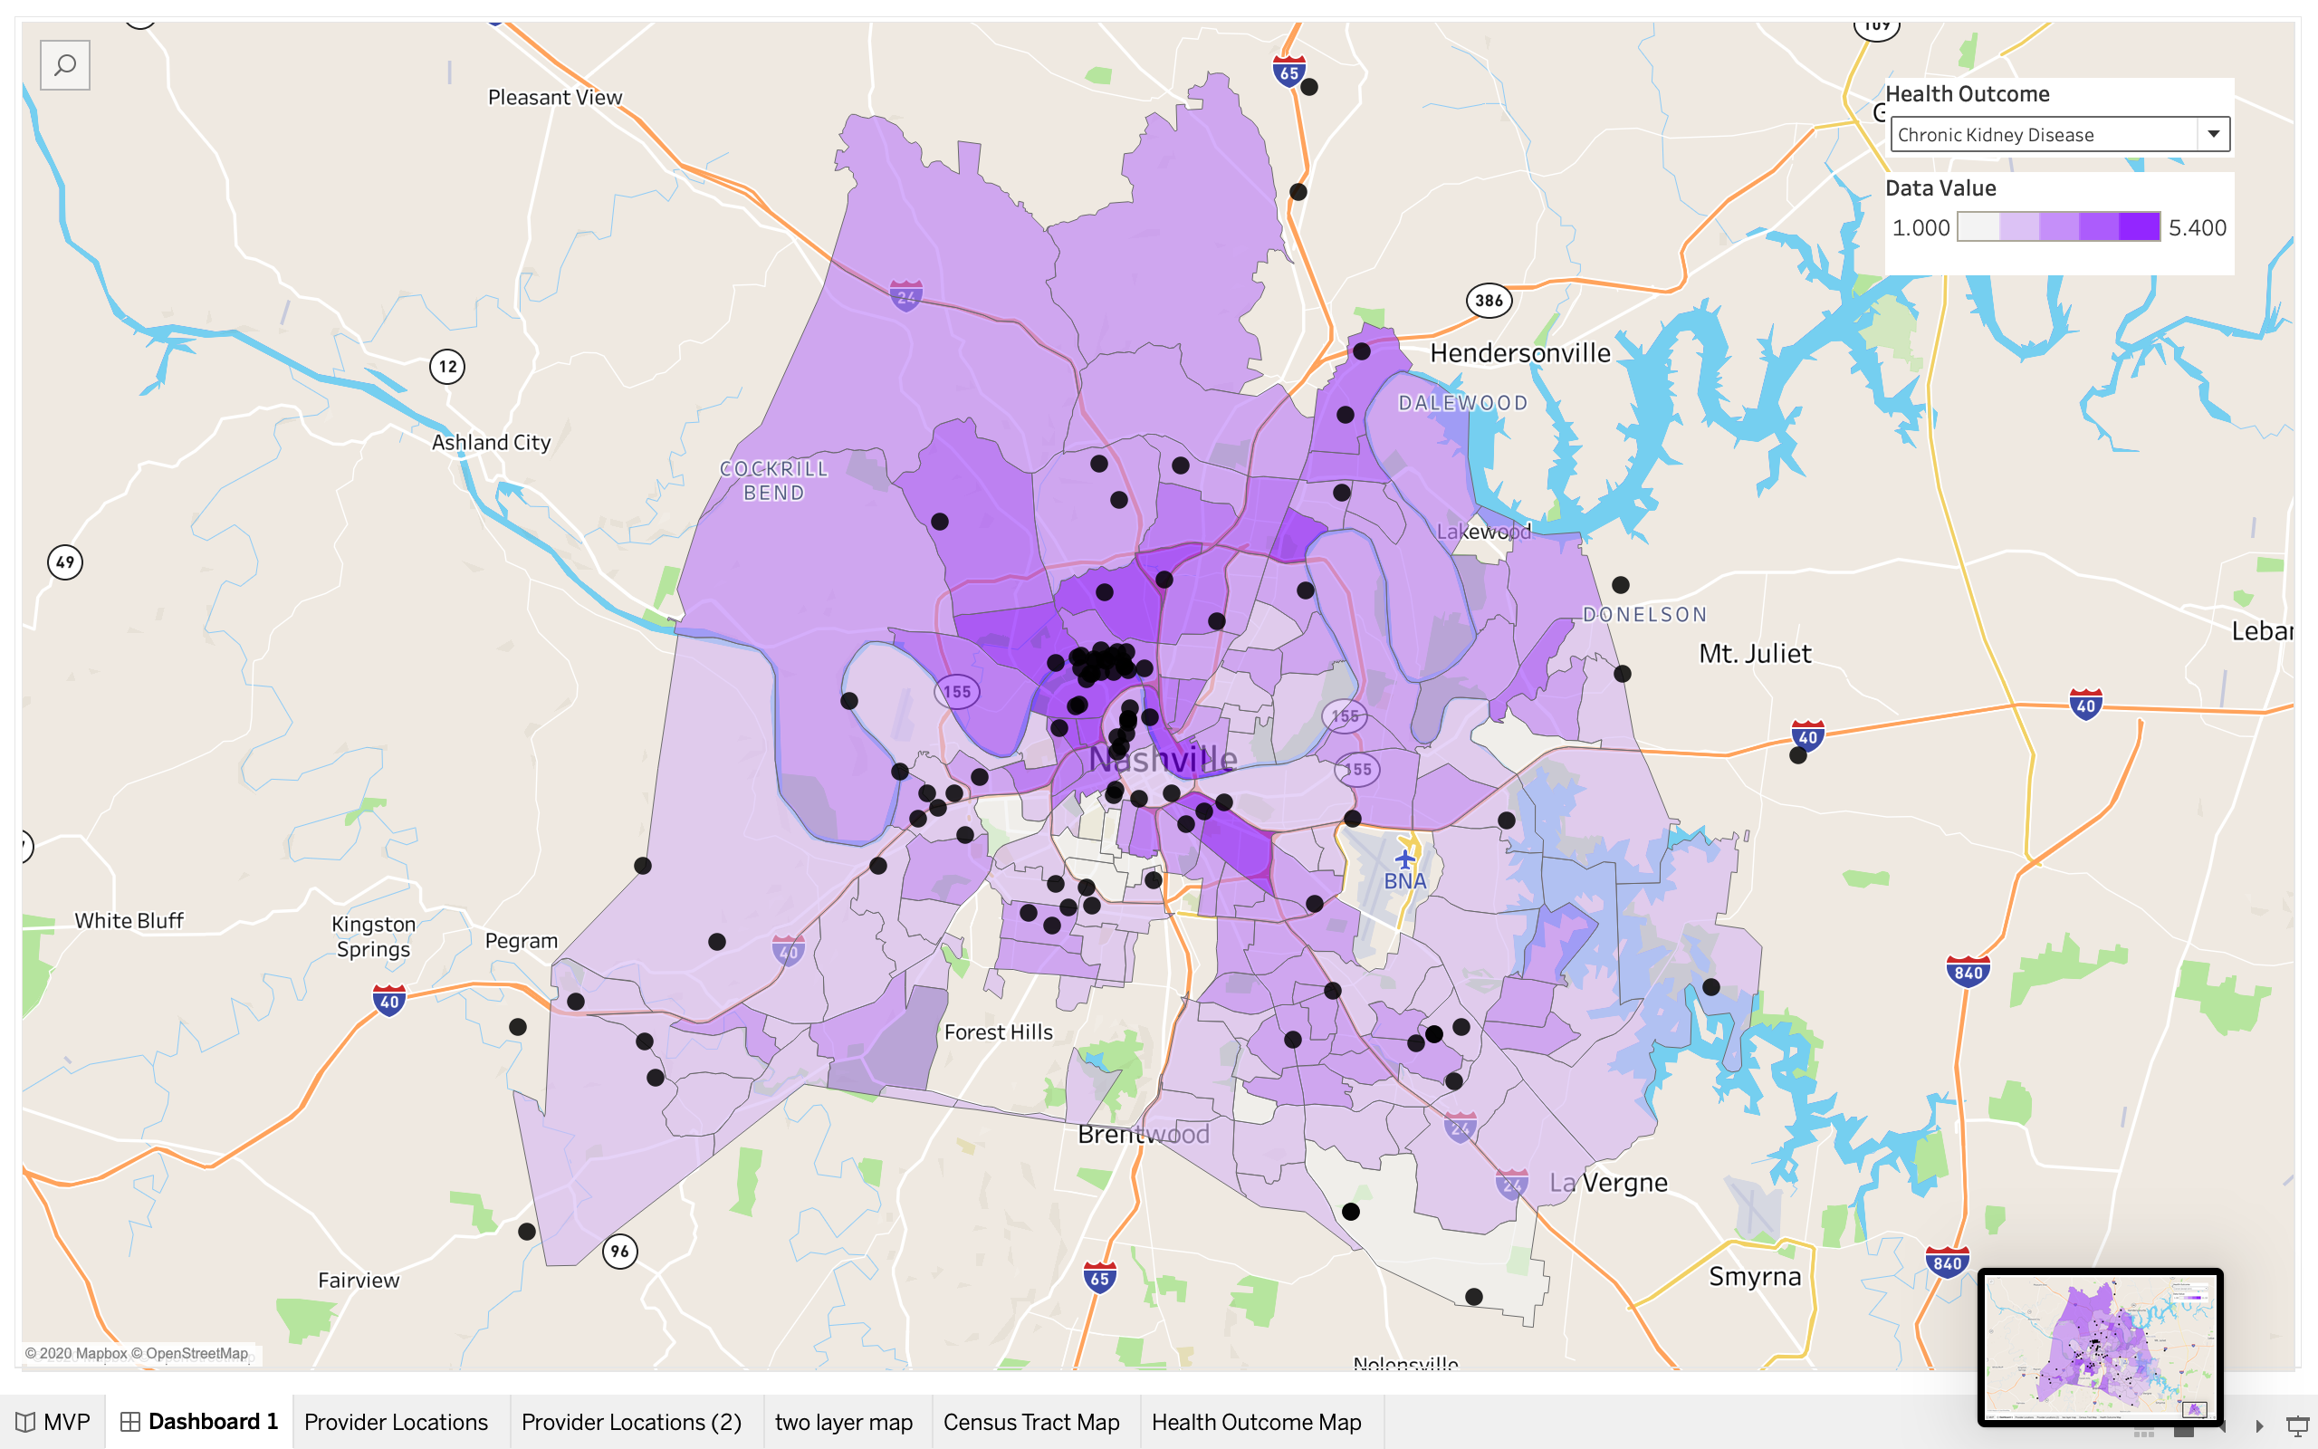
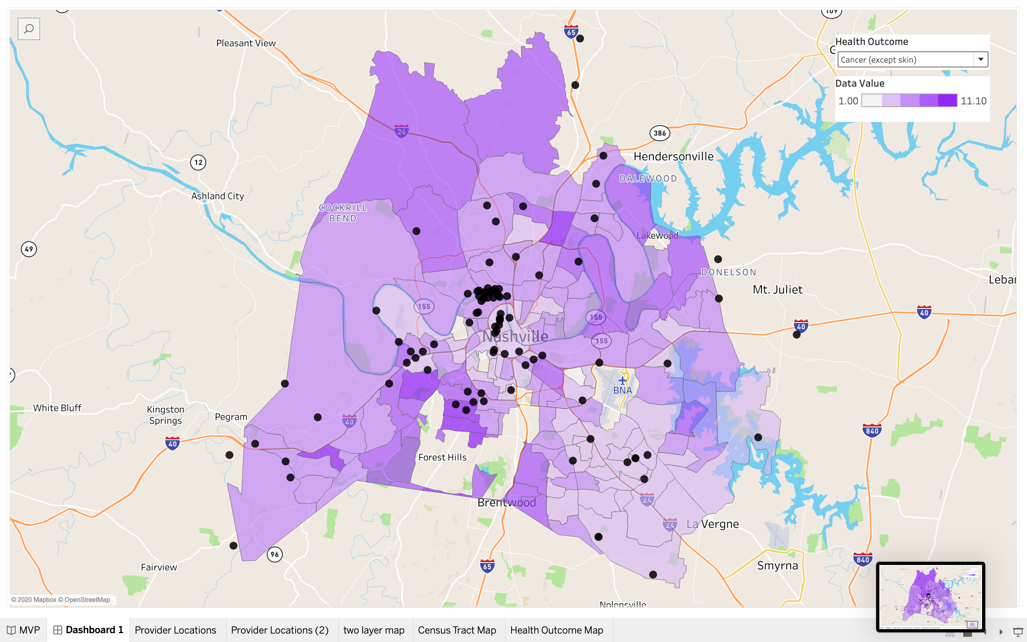
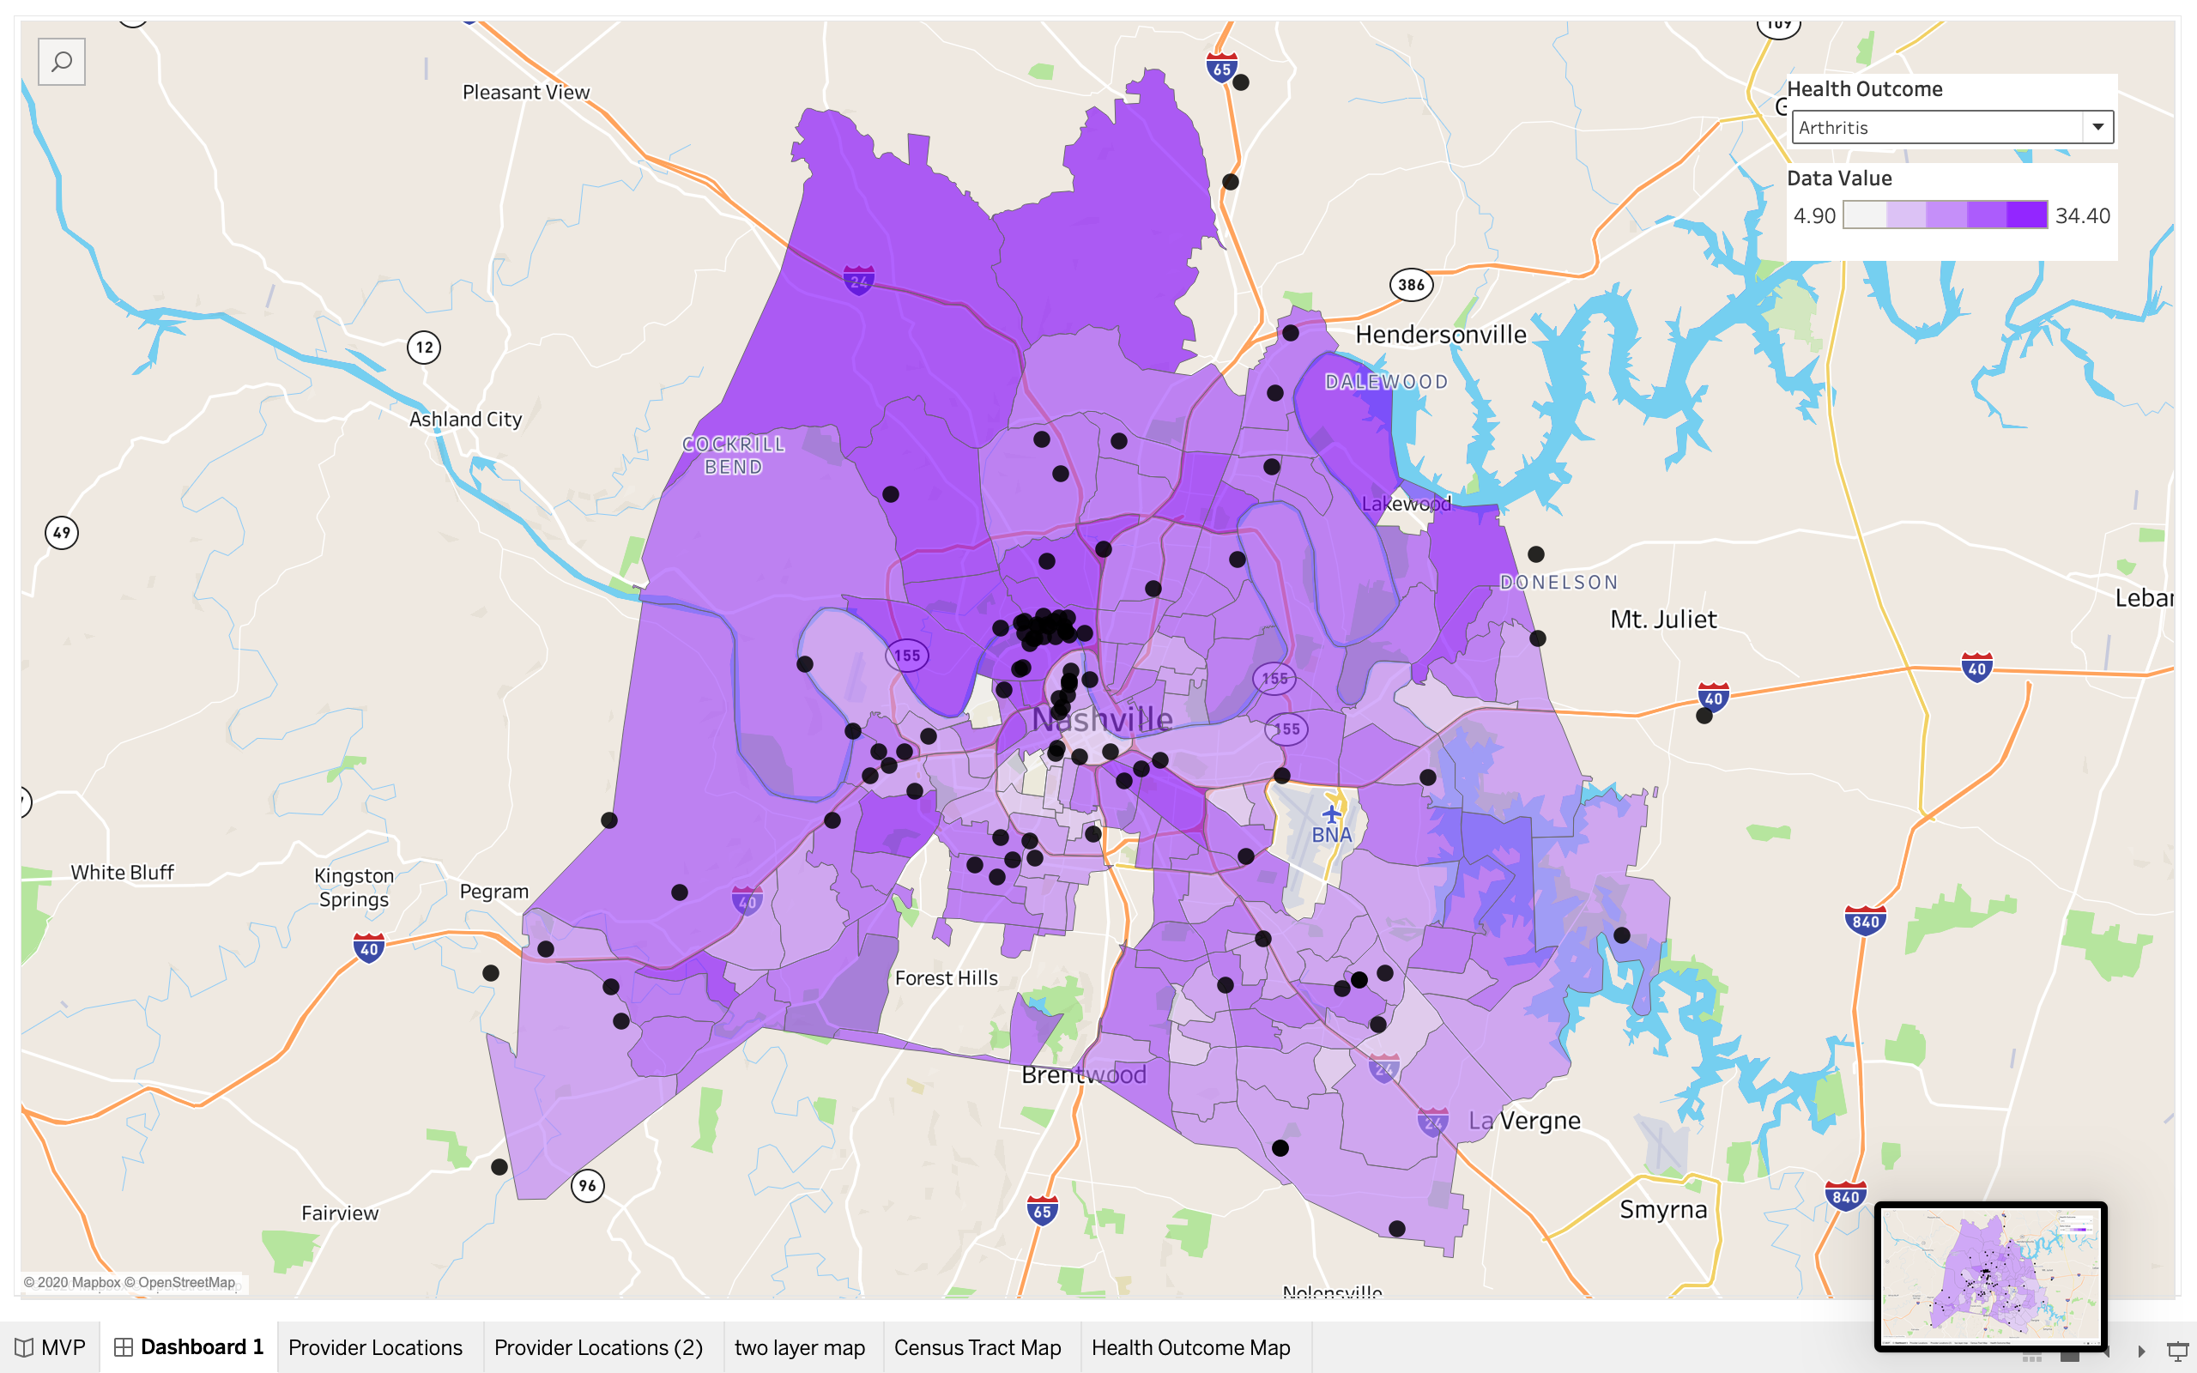
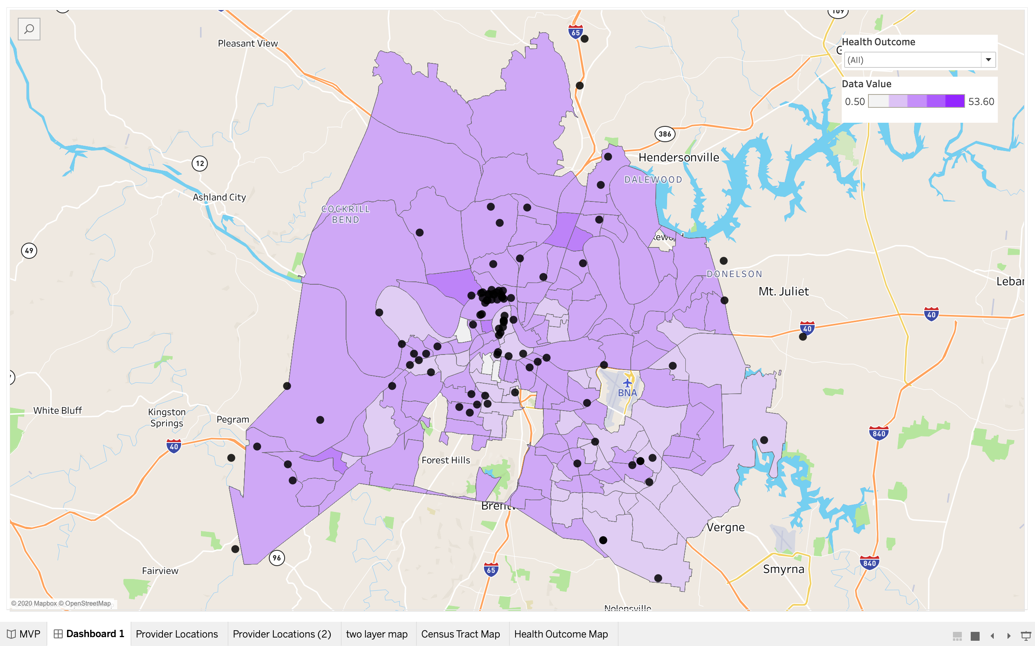

500 Cities Data Files
Need to understand what this data is saying. Here is info from the website: https://www.cdc.gov/500cities

Measures
The 27 measures include 5 unhealthy behaviors, 13 health outcomes, and 9 prevention practices.
The measures include major risk behaviors that lead to illness, suffering, and early death related to chronic diseases and conditions, as well as the conditions and diseases that are the most common, costly, and preventable of all health problems.
Each measure will have a comprehensive definition that includes the background, significance, limitations of the indicator, data source, and limitations of the data resources.
Measures will complement existing sets of surveillance indicators that report state, metropolitan area, and county-level data, including County Health Rankings, Chronic Disease Indicators, and Community Health Status Indicators.

Unhealthy Behaviors
- Binge drinking among adults aged ≥18 years
- Current smoking among adults aged ≥18 years
- No leisure-time physical activity among adults aged ≥18 years
- Obesity among adults aged ≥18 years
- Sleeping less than 7 hours among adults aged ≥18 years

Health Outcomes
- Arthritis among adults aged ≥18 years
- Current asthma among adults aged ≥18 years
- High blood pressure among adults aged ≥18 years
- Cancer (excluding skin cancer) among adults aged ≥18 years
- High cholesterol among adults aged ≥18 years who have been screened in the past 5 years
- Chronic kidney disease among adults aged ≥18 years
- Chronic obstructive pulmonary disease among adults aged ≥18 years
- Coronary heart disease among adults aged ≥18 years
- Diagnosed diabetes among adults aged ≥18 years
- Mental health not good for ≥14 days among adults aged ≥18 years
- Physical health not good for ≥14 days among adults aged ≥18 years
- All teeth lost among adults aged ≥65 years
- Stroke among adults aged ≥18 years

Prevention
- Current lack of health insurance among adults aged 18-64 years
- Visits to doctor for routine checkup within the past year among adults aged ≥18 years
- Visits to dentist or dental clinic among adults aged ≥18 years
- Taking medicine for high blood pressure control among adults aged ≥18 years with high blood pressure
- Cholesterol screening among adults aged ≥18 years
- Mammography use among women aged 50-74 years
- Papanicolaou smear use among adult women aged 21-65 years
- Fecal occult blood test, sigmoidoscopy, or colonoscopy among adults aged 50-75 years
- Older adults aged ≥65 years who are up to date on a core set of clinical preventive services (Men: Flu shot past year, Pneumococcal polysaccharides vaccine (PPV) shot ever, Colorectal cancer screening; Women: Same as above, and Mammogram past 2 years)

Measure Definitions
Measure Definitions are divided into the three Areas below. Each Area contains info on the 27 measures.
- Health Outcomes
- Prevention
- Unhealthy Behaviors

Measure Definitions Sample: Health Outcomes for Arthritis
Demographic group
Resident adults aged ≥18 years.
Numerator
Respondents aged ≥18 years who report having been told by a doctor, nurse, or other health professional that they had arthritis.
Denominator
Respondents aged ≥18 years who answered “yes” or “no” to the following question: “Have you ever been told by a doctor, nurse, or other health professional that you have some form of arthritis, rheumatoid arthritis, gout, lupus, or fibromyalgia?” (excluding those who refused to answer, had a missing answer, or answered “don’t know/not sure”).
Measures of frequency
Annual prevalence (years 2011–2015) with 95% confidence intervals and by demographic characteristics when feasible.
Time period of case definition
Lifetime.
Background
An estimated 52.5 million adults have physician-diagnosed arthritis, and 22.7 million report arthritis-attributable activity limitations (1). As the population ages, arthritis is expected to affect an estimated 67 million adults in the United States by 2030 (2). In 2003, arthritis cost an estimated $128 billion in direct medical and indirect costs (3).
Significance
Monitoring the prevalence and public health effects of arthritis are important for estimating the state-specific need for interventions that reduce symptoms, improve physical function, and improve the quality of life for persons with arthritis. These interventions include self-management education programs that have been shown to reduce pain and improve psychological health and health behaviors and physical activity programs that have been shown to improve physical function, mental health, and quality of life.
Limitations of indicator
Physician-diagnosed arthritis is self-reported in the Behavioral Risk Factor Surveillance System and was not confirmed by a health-care provider or objective monitoring; however, such self-reports have been shown to be acceptable for surveillance purposes (4) (despite minor changes made in 2011 to the case-finding question to include arthritis on the chronic conditions core).
Data resources
Behavioral Risk Factor Surveillance System (BRFSS).
In addition, CDC typically provides this estimate in standard arthritis BRFSS tables produced for each state for odd-numbered years. Unadjusted data are usually presented in these tables to provide actual estimates to help in state-level program planning.
Limitations of data resources
As with all self-reported sample surveys, BRFSS data might be subject to systematic error resulting from non-coverage, nonresponse, or measurement bias. In an effort to address non-coverage issues related to phone use, BRFSS began including cell phone interviews in the 2011 data collection. Due to changes in sampling and weighting methodology, 2011 is a new baseline for BRFSS, and comparisons with prior year data are inappropriate.
Related
dfdfdf

